Jie MEI 1030-29-9698

Fokker-Planck Equation

The Fokker-Planck equation is the equation governing the time evolution of the probability density of the Brownian particle. As the time passing, you can see the probability density of the velocity of Brownian particle flow into equivalent state under the influence of drag forces and random forces.

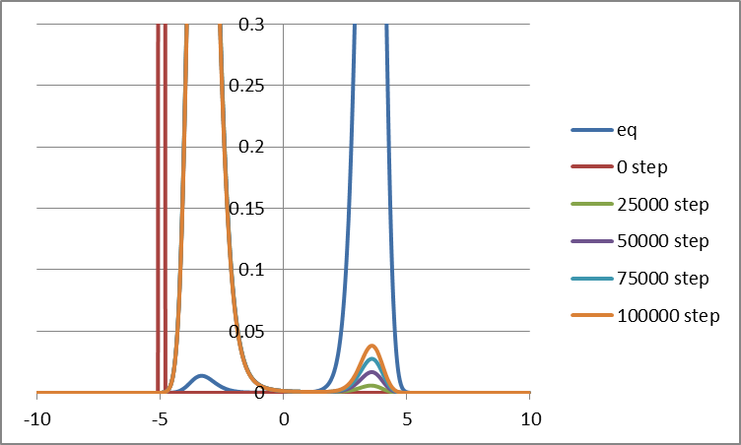

Fig.1 The time evolution of the probability density function of velocity under T = 10

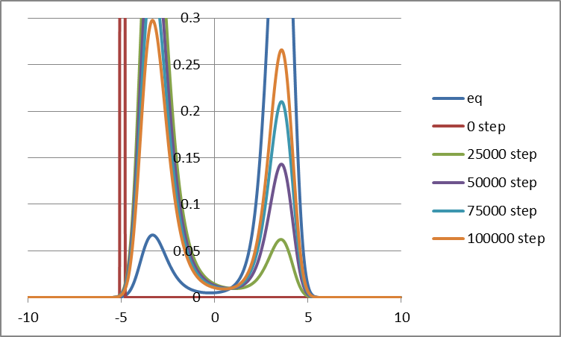

Fig.2 The time evolution of the probability density function of velocity under T = 20

In the case of one-dimensional Fokker–Planck equation, the initial condition is a Dirac delta function centered away from zero velocity. Over time the distribution widens due to random impulses.

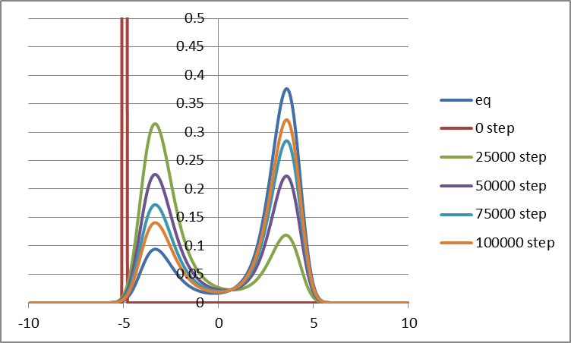

Fig.3 The time evolution of the probability density function of velocity under T = 30

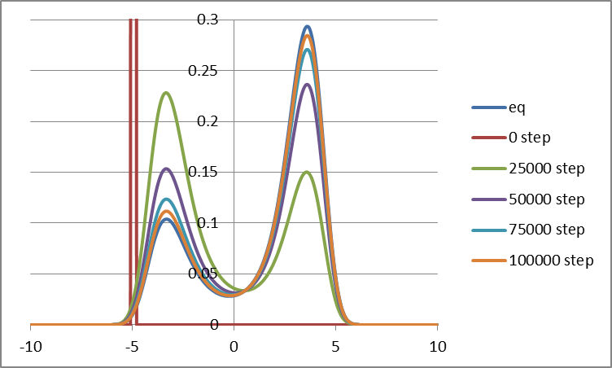

Fig.4 The time evolution of the probability density function of velocity under T = 40

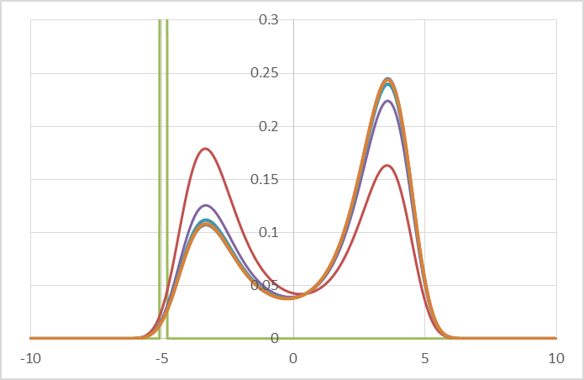

Fig.5 The time evolution of the probability density function of velocity under T = 50

As the velocity distribution is directly correlative to the Boltzmann distribution, the equivalent probability density of the velocity will decrease with the decline of the temperature.

At the same time, we bring the entropy into account, especially under the inequivalent state. With the combination of the law of thermodynamics and the Boltzmann function, we can get the Shannon entropy, which is drawn as followed with different temperatures.

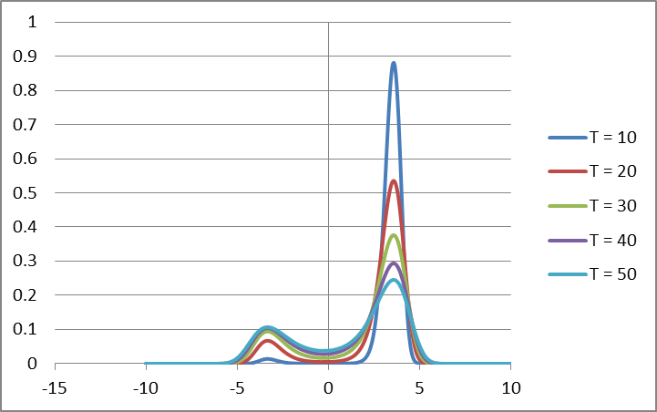

Fig.6 The probability density of the velocity in equivalent state with different temperature

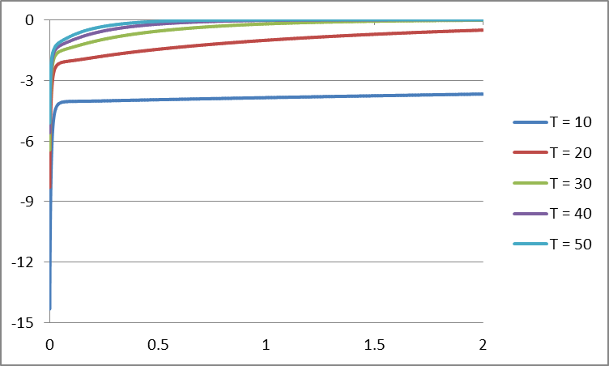

Fig.7 The Shannon entropy in inequivalent state with different temperature from 10 to 50

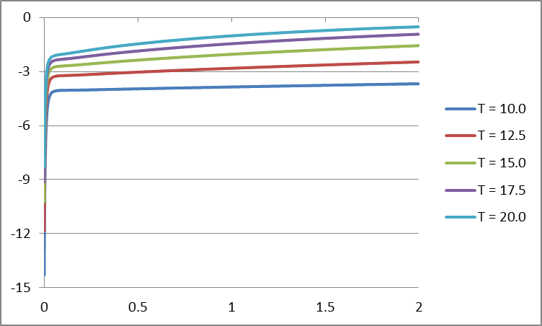

Fig.8 The Shannon entropy in inequivalent state with different temperature from 10 to 20

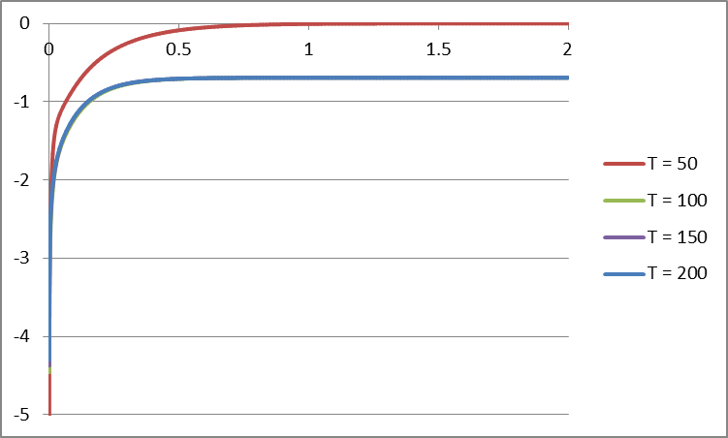

Fig.9 The Shannon entropy in inequivalent state with different temperature from 50 to 200

As the figure 7 and 8 shown, we can easily imply that with higher temperature will get closed to 0 faster. But in figure 9, we can see that after the temperature increases higher than 50, the speed of entropy getting closed to 0 will not become faster.

Bibliography:

[1] Brownian Motion: Fokker-Planck Equation: Chapter 7, Lennart Sjogren, University of Gothenburg

[2] Fokker–Planck equation, Wikipedia:

<https://en.wikipedia.org/wiki/Fokker%E2%80%93Planck_equation>

[3] Entropy in thermodynamics and information theory, Wikipedia:

<https://en.wikipedia.org/wiki/Entropy_in_thermodynamics_and_information_theory>

[4] Boltzmann distribution, Wikipedia:

<https://en.wikipedia.org/wiki/Boltzmann_distribution>